Ex. No. 3 | Sequence Diagram
Date of Exercise | 17-01-2017

Aim
To draw a Sequence Diagram diagram for on-line railway reservation system
Youtube link : https://youtu.be/hpziBbkehcc
Description
Sequence diagrams demonstrate the behavior of objects in a use case by describing the objects and the messages they pass. The diagrams are read left to right and descending. The example below shows an object of class 1 start the behavior by sending a message to an object of class 2. Messages pass between the different objects until the object of class 1 receives the final message.

In a Sequence diagram, classes and actors are listed as columns with vertical lifelines indicating the lifetime of the object over time.

Object
Objects are instances of classes, and are arranged horizontally. The pictorial representation for an object is a class (a rectangle) with the name prefixed by the object name (optional) and a semi-colon.

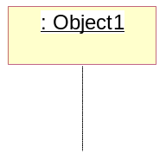

Actor
Actors can also communicate with objects, so they too can be listed as a column. An Actor is modeled using the ubiquitous symbol, the stick figure.
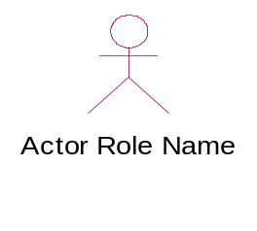
Lifeline
The Lifeline identifies the existence of the object over time. The notation for a Lifeline is a vertical dotted line extending from an object.
|
|
|

Activation
Activations, modeled as rectangular boxes on the lifeline, indicate when the object is performing an action.

Message
Messages, modeled as horizontal arrows between Activations, indicate the communications between objects.

Scenario of the application
The sequence diagrams defines the flow of instructions through the actors defined in the on-line railway reservation system. The following sequence diagrams shows how the commands are given through the actors in the use case diagram. Each state of the actors while on the system is clearly defined and the responses is shown.

Sequence Diagram for the application
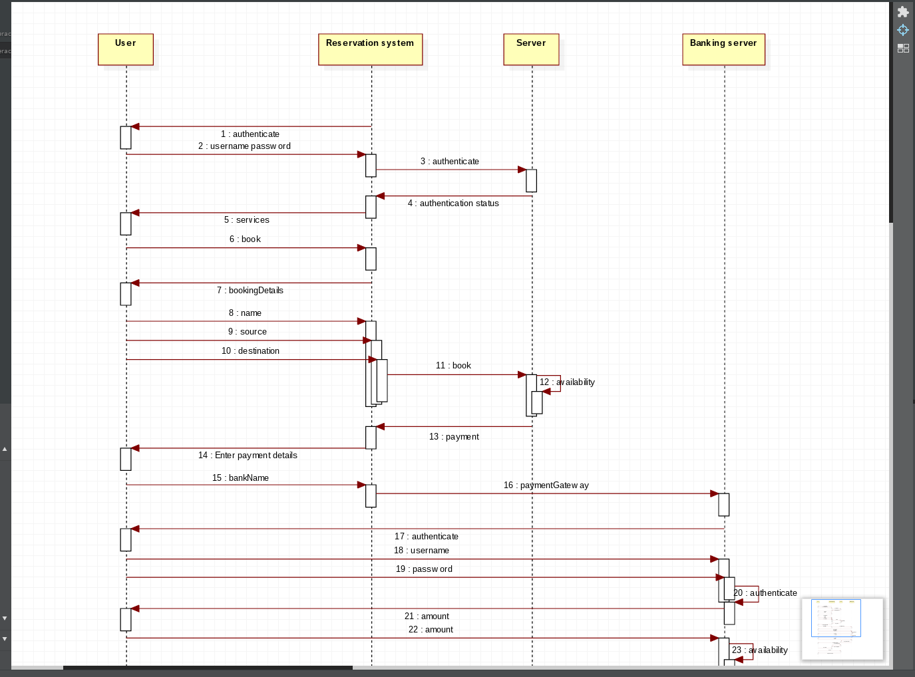
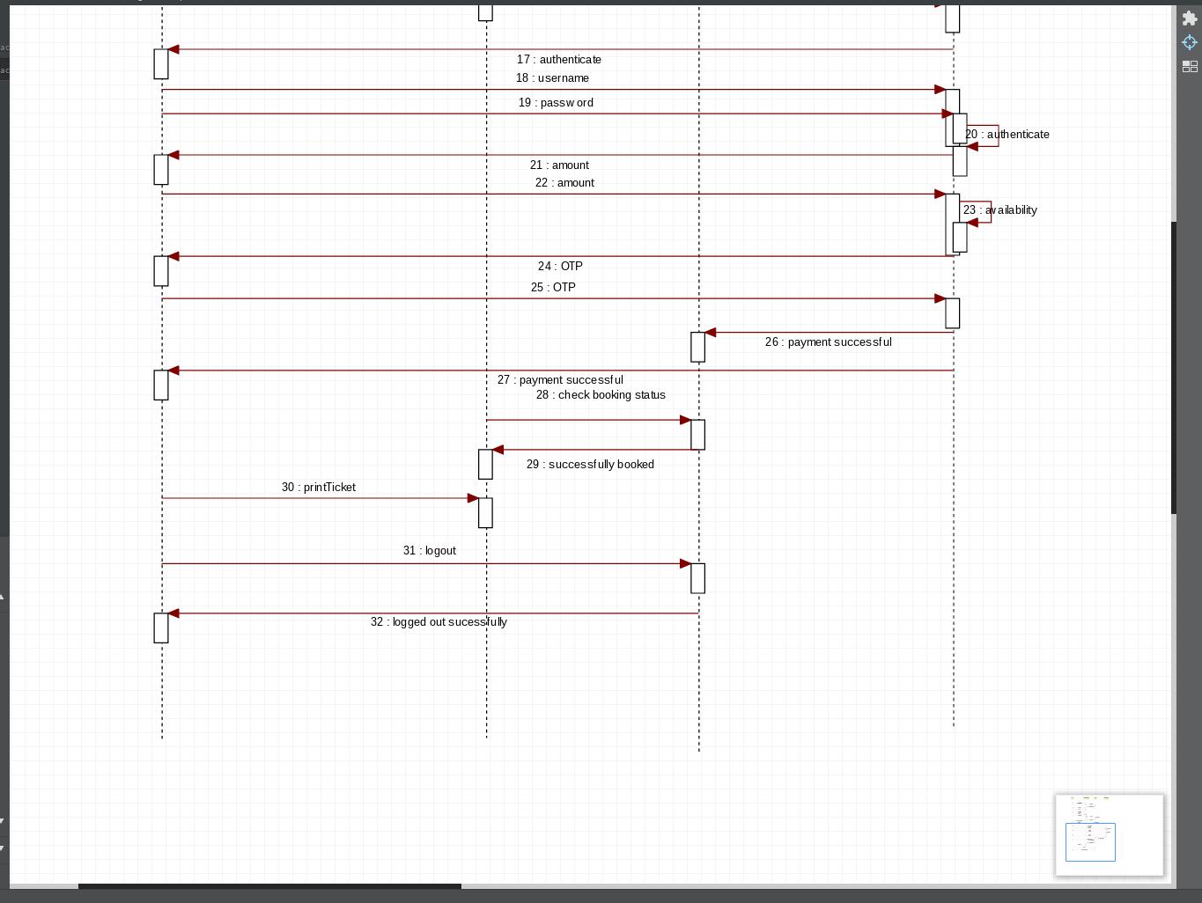

Functionalities of the objects used
Usecase name | Explanation
Check Ticket Availability  Pay fare amount  Book ticket  Fill out personal details  Cancel ticket  Refund money | Used to check ticket availability from the railway database  Traveller pays the amount and saves it in the database  After paying the amount,the traveler shall be able to book the ticket.Hence use case of pay fare amount is included in book ticket  The traveler fills out the personal details after choosing the option of booking ticket  Used to cancel the ticket and the database is updated  Used to refund money and updated in the database

Result
The sequence diagram for on-line railway reservation is completed and verified.

